

AN: ISO 9001: 2015 (QMS) & ISO 14001: 2015 (EMS), RoHS

MANUFACTURER OF:


Networking Racks, Server Racks, Outdoor Racks, Electrical Panels, Junction Box Email: info@innoracks.in Website: www.innoracks.in
Phone No: 0129-2985686

ACCESSORIES

POWER DISTRIBUTION UNIT (PDU)

Horizontal Power Distribution Unit (H/PDU)
Vertical Power Distribution Unit (V/PDU)

Model Name | Model Specifications | Description
INN/H/PDU/001 | 6S X 5AMP:  6 sockets: 6 AMP | With Switch & Indicator
INN/H/PDU/002 | 6S X 15AMP:  6 sockets: 6/15AMP | With Switch & Indicator
INN/V/PDU/003 | 10S X 5AMP:  10 sockets: 6 AMP | With Switch & Indicator
INN/V/PDU/004 | 10S X 5AMP:  10 sockets: 6/15 AMP | With Switch & Indicator
INN/V/PDU/005 | 12S X 15AMP:  12 sockets: 6/15AMP | With Switch & Indicator
INN/V/PDU/006 | 10M X 15:  10 sockets: 6/15AMP | With MCB
INN/V/PDU/007 | 12M X 15 AMP:  12 sockets: 6/15AMP | With MCB

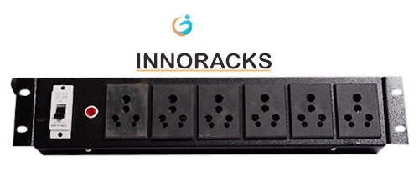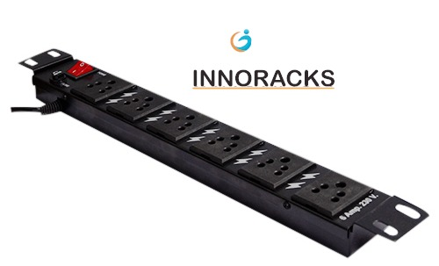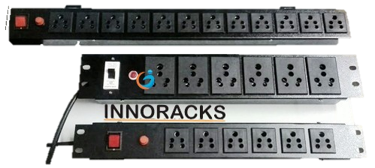

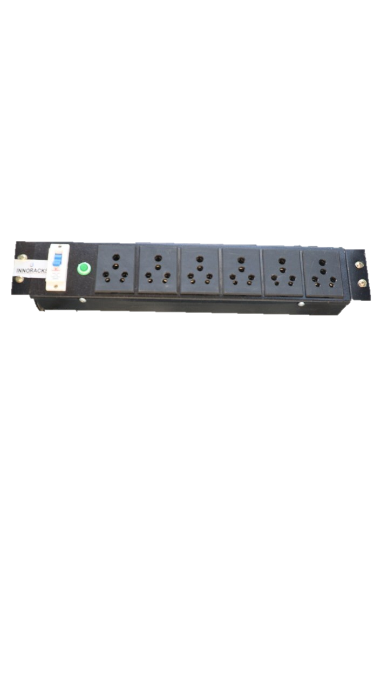

CPU TROLLY

Product Specification

Name | Description
Color | Black, Ivory
Material | Mild Steel(powder coated)
Size(in MM) | 240(L)X240(W)X150(H)
Width | Adjustable (150MM to 225MM)
Loading Capacity | 20kg
Technology | Machine Cutting
Accessories | Swivel 4 Castor wheels (2 with brakes & 2 regular wheels)  Rubber shock absorbers  Screws & Nuts (Hardware)
Features | Lockable wheels (to station Trolley at one place)  Adjustable design to fit all sizes of CPUs  Easy to handle, transport & assemble  Excellent finish & Durable

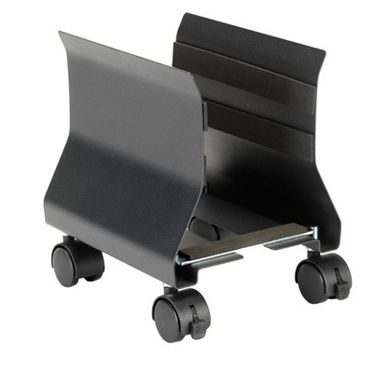

CANTILEVER TRAY

Part Name | Model Name
INN-CNT-001 | 1U - 435MM (Front)
INN-CNT-001 | 1U - 250MM (Depth)
INN-CNT-001 | Can be used from 2 TO 50U (Customization available) for all 19” maintained equipment

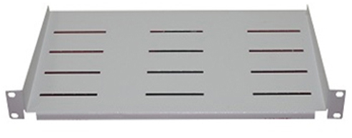

KEYBOARD TRAY/SLIDING TRAY

Part Name | Model Name
INN-KBT-001 | For up-to 1000MM Rack

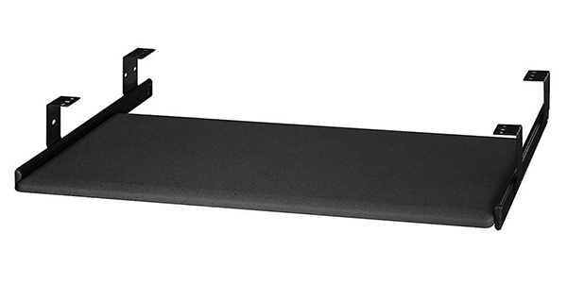

BLANK PANEL

Part Name | Model Name
INN-BLANK-001 | 1U- Blank Panel
INN-BLANK-002 | 2U- Blank Panel
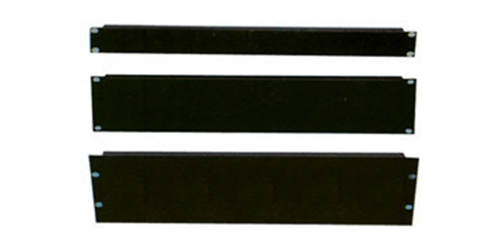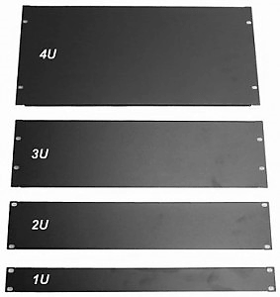

CABLE MANAGER

Part Name | Model Name | Used In
INN-PVC-001 | PVC Cable Manager | 2U- 42U
INN-MET-002 | Metallic Cable Manager | 2U- 42U

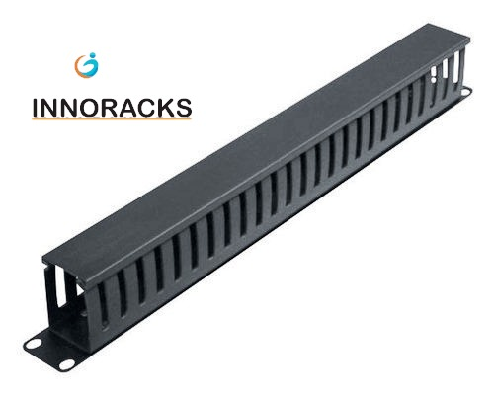

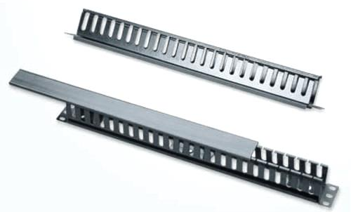

SHELF

Part Name | Model Name | Used In
INN-SHELF-001 | 375MM | RACKS 600MM X 600MM
INN-SHELF-002 | 425MM | RACKS 600MM X 600MM
INN-SHELF-003 | 475MM | RACKS 600MM X 800MM
INN-SHELF-003 | 475MM | RACK 800MM X 800MM
INN-SHELF-004 | 525MM | RACKS 600MM X 800MM
INN-SHELF-004 | 525MM | RACKS 800MM X 800MM
INN-SHELF-005 | 725MM | RACKS 800MM X 1000MM
INN-SHELF-006 | 925MM | RACKS 600MM X 1200MM
INN-SHELF-006 | 925MM | RACKS 800MM X 1200MM
